**Thin Provisioning Volume in LVM**

1. Check system IP-



2. Add a hard disk of 50GB & verify it-

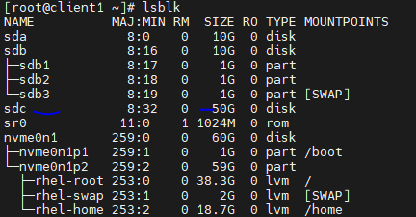

3. Create a partition “sdc1” of 30GB in disk “sdc” & run partprobe to let kernel know about it-

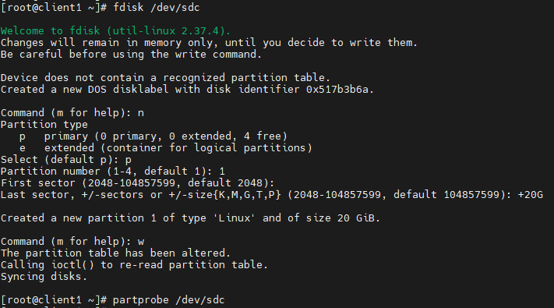

4. Verify this newly created partition-

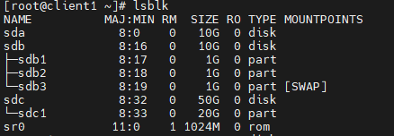

5. Create physical volume using this partition-



6. Create a volume group with 32MB physical extent using this physical volume-



7. Verify whether this newly created volume group has 32MB PE (Physical Extent)-

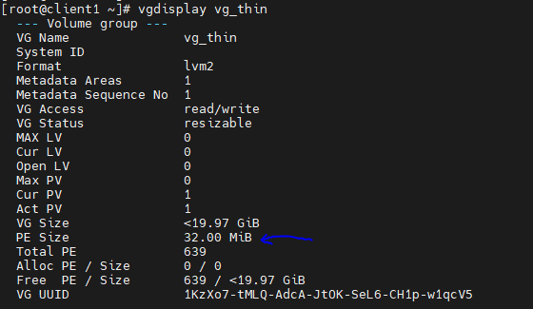

8. Next, create a thin pool using this volume group. It will be used for allocating space to logical volume which will be created in future-



9. Verify this thin pool-

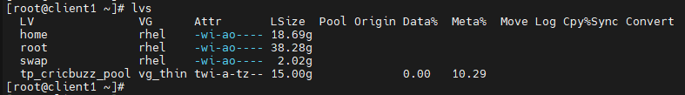

Here, ‘t’ stands for thin provisioning.

10. We will confirm the same using lsblk-

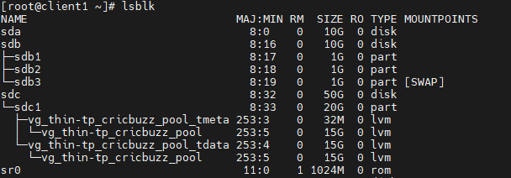

It shows this pool created.

11. To get more detail about this thin pool use command shown below-

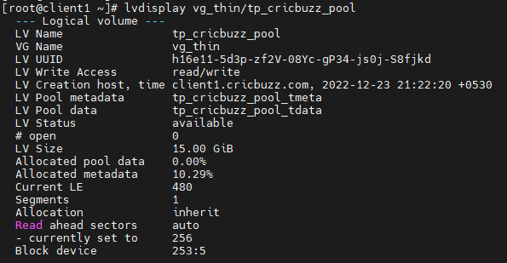

12. Now, we will create logical volume from the space of thin pool & verify it-



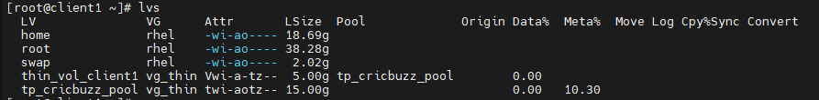

Now thin pool will have 10GB space available to allocate for other future logical volumes.

13. We will create two more logical volume as shown & verify it-

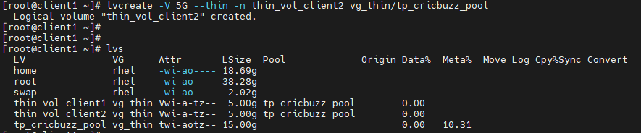

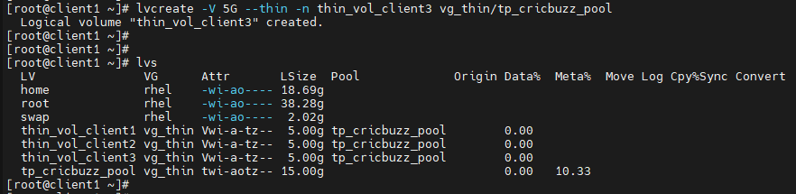

14. We will create three directories inside /mnt to mount these three LV-

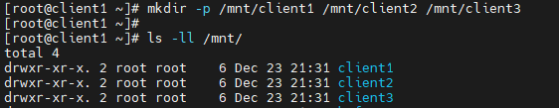

15. Next, we will format these LVs using ext4 file system. We will use ‘&&’ operator to do this at once-

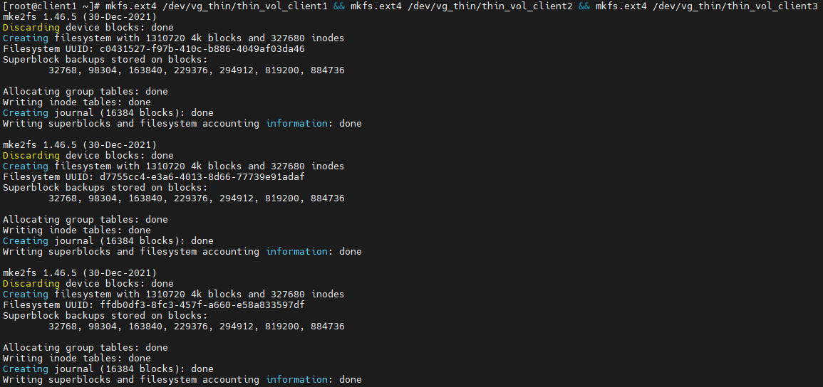

16. Verify these formatted LVs-

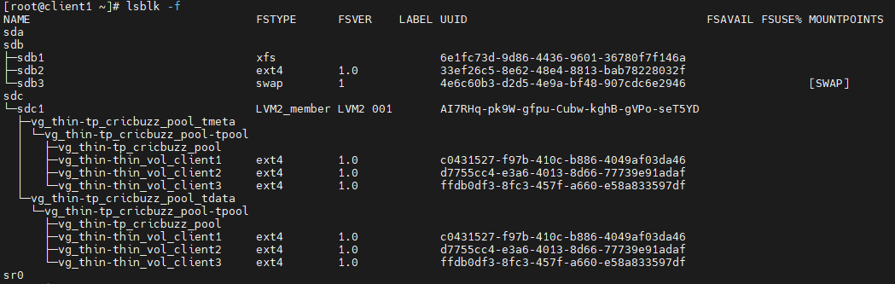

17. We will mount these LVs to the directory created earlier-

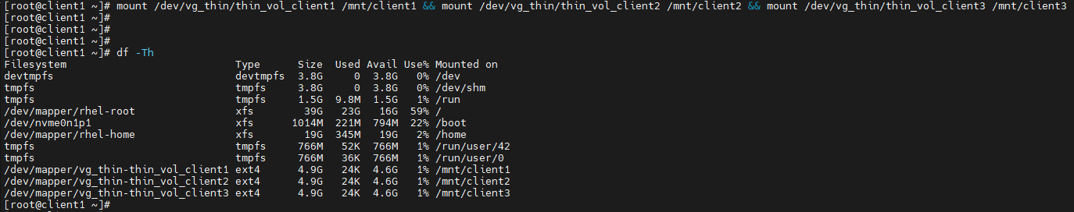

18. Go to /mnt/client1 & add file of 2GB in size-

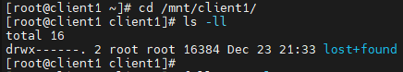

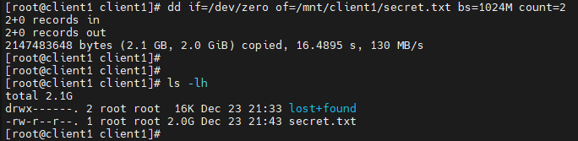

19. Check total space utilized (See Data% column) by the LV & show same for thin pool-

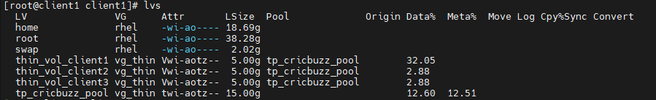

20. Do the same for /mnt/client2-



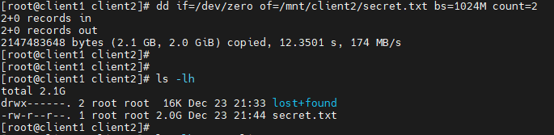

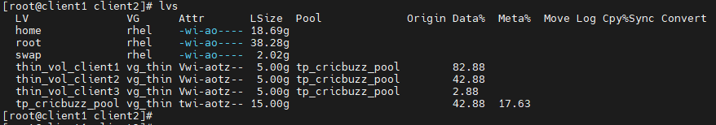

21. In the same way, do for /mnt/client3-

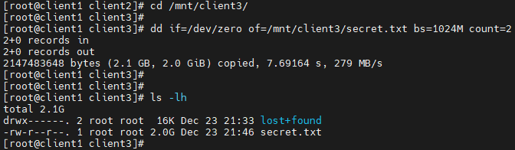

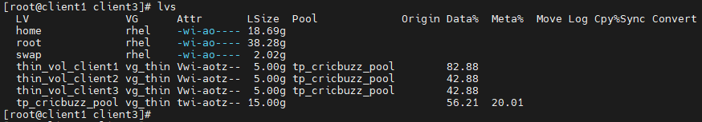

22. Now, we want to add another LV of 5GB using thin pool space. In normal LVM case, it won’t allow us to create another LV as pool space is completely assigned to three LVs. But in case of thin provisioning, we can do that. It will take unused space from the already created LVs & used them to allocate space to new LV. It is risky as well, cause once other LVs space is utilized by themselves, data will get corrupted. So, we always have to monitor pool space. It should not be completely utilized.

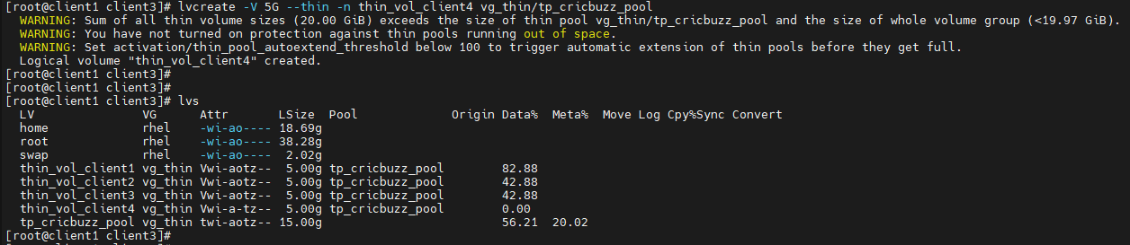

Currently, space utilization for pool is 56.21%. We can see the warning message. Here, we will format this newly created LV using ext4 & mount it on /mnt/client4. For that, first we need to create this directory.

23. Verify this newly created LV using lsblk-

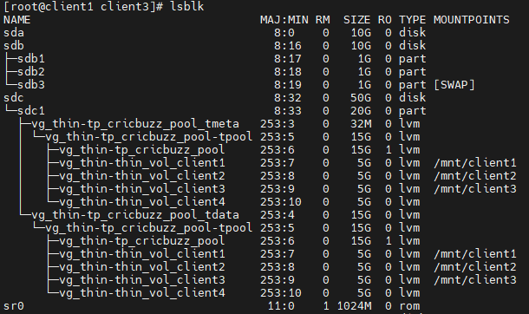

24. Check the available volume group space as we want to extend pool size by 15GB, to avoid data loss-

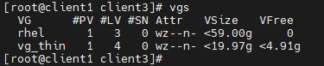

25. Currently we have 30GB space available in disk ‘sdc’. We will use this complete space to create a new partition ‘sdc2’-

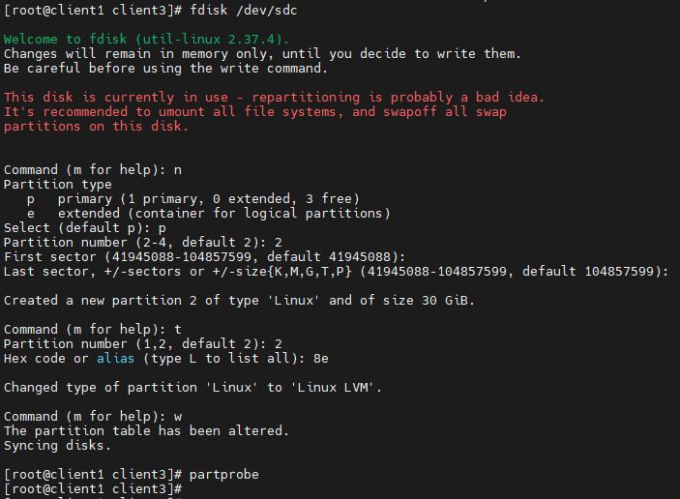

26. We can verify the same using lsblk-

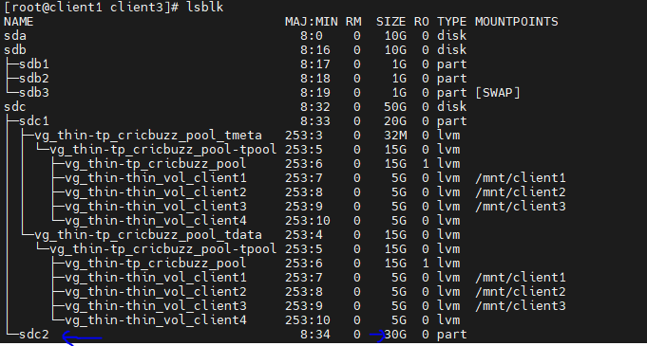

27. Create new physical volume using this new partition & verify it-

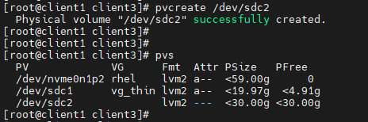

28. Now, extend volume group by using this PV & verify-

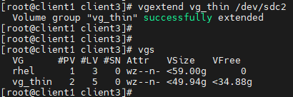

29. Extend the logical volume pool by 15GB-



30. Verify volume group again after taking 15GB from it-

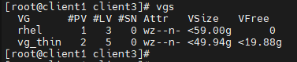

31. At last, check the updated thin pool size & current utilization-

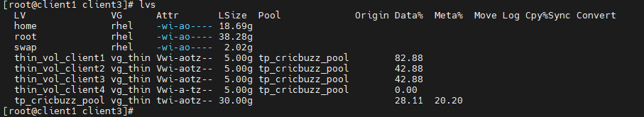

This is it!!!